**Title: Protected area planning to conserve biodiversity in an uncertain world**

**Authors:** Richard Schuster 1,2*, Rachel Buxton1, Jeffrey O. Hanson1, Allison D. Binley1, Jeremy Pittman3, Vivitskaia Tulloch4, Frank A. La Sorte5, Patrick R. Roehrdanz6, Peter H. Verburg7, Amanda D. Rodewald5,8, Scott Wilson1,9, Hugh P. Possingham10, Joseph R. Bennett1

**Affiliations:**

1 Department of Biology, 1125 Colonel By Drive, Carleton University, Ottawa ON, K1S 5B6 Canada.

2 Nature Conservancy of Canada, 245 Eglinton Ave East, Suite 410, Toronto, Ontario, M4P 3J1, Canada.

3 School of Planning, University of Waterloo, 200 University Ave W, Waterloo, ON, N2T 3G1, Canada

4 Conservation Decisions Lab, Department of Forest and Conservation Sciences, 2424 Main Mall, Vancouver, BC V6T 1Z4, Canada.

5 Cornell Lab of Ornithology, Cornell University, Ithaca, NY 14850, USA

6 Conservation International, 2100 Crystal Drive #600, Arlington, VA 22202, USA

7 Institute for Environmental Studies, VU University Amsterdam, Amsterdam, The Netherlands

8 Department of Natural Resources and the Environment, Cornell University, Ithaca, NY 14853, USA.

9 Wildlife Research Division, Environment and Climate Change Canada, 1125 Colonel By Drive, Ottawa, Ontario, Canada, K1S 5B6

10 Centre for Biodiversity and Conservation Science, University of Queensland, St Lucia, Queensland 4067, Australia

*Corresponding author. Email: [richard.schuster@glel.carleton.ca](mailto:richard.schuster@glel.carleton.ca)

Running title: Protected area planning in an uncertain world

Keywords: biodiversity, protected areas, optimization, risk, governance, land use, climate change, optimization

Number of words (Abstract):

Number of words (Manuscript):

Number of figures: 4

Number of tables: 0

Number of references:

**Abstract:**

Protected areas are a key instrument for conservation. Despite this, they are vulnerable to risks associated with weak governance, land use intensification, and climate change. Using a novel hierarchical optimization routine, we identified priority areas for expanding the global protected area system to explicitly account for such risks whilst maximizing protection of all known terrestrial vertebrate species. We found that these priority areas encompassed only a slightly larger percentage of land compared with those generated using conventional methods that fail to account for risks. Among the three risk categories, the risk of governance failure drove the biggest changes among priority areas. To reduce risk of governance failure, more priority areas were sited in countries with strong governance to protect wide-ranging species that inhabit multiple countries. Our findings show how conservation plans can overcome multiple sources of risk and also underscore the need for cross-jurisdictional coordination.

**Introduction**

**Protected area**s are one of the best strategies for stemming decline in biodiversity (Watson et al. 2014). With limited resources available, plans for expanding the global protected area system must be cost-effective. land area have a Although approaches for developing such plans often account for the spatial patterns of biodiversity, land-use, and management costs (Venter et al. 2014), they often assume that protected areas, once implemented, are guaranteed to conserve biodiversity. Yet many existing protected areas lack the necessary enforcement, effective management, and long-term support to safeguard species and ecosystems (CITATION). For example, political instability and corruption reduce management effectiveness (Hammill et al. 2016; Schulze et al. 2018); landscapes with high deforestation rates have increased chances of protected area degazettement (Tesfaw et al. 2018 ); and the increasing frequency and intensity of extreme weather events due to climate change threatens populations within protected areas (Maxwell et al. 2019). Thus failing to account for such risk factors when developing conservation plans could lead to the establishment of protected areas in places where they have a high chance of failing to safeguard biodiversity (McBride et al. 2007).

Here we show how explicitly accounting for risk of failure can alter conservation priorities at the global scale To achieve this, we considered the following three broad categories of risk, which we defined as factors likely to diminish the long-term effectiveness of protected areas: (i) governance, (ii) land use, and (iii) climate. We then generated plans for establishing protected areas (“prioritizations”) based on scenarios for different risk factors. Our framework provides a flexible approach for incorporating risk metrics into conservation decision making (Garcia et al. 2014).

**Methods**

We considered the influence of risk categories on allocating protection decisions at a global scale in suitable habitat for all 29,350 vertebrate species from the IUCN Red List of Threatened Species (IUCN 2019) using a multi-objective optimization approach. To incorporate risk categories, we built on the minimum set problem, where the objective is to meet species distribution protection targets while accounting for one constraint such as land cost or area ( Ball et al. 2009; Moilanen et al. 2009). We expanded this approach to include multiple objectives accounting for risk in the problem formulation, by treating each risk layer as a separate objective in the problem formulation (Deb 2014).

Biodiversity Data

We produced A rea of H abitat (AOH) for 10,774 species of birds, 5,219 mammals, 4,462 reptiles and 6,254 amphibians with available IUCN range polygon data following the procedure outlined in Brooks et al. (2019). Species range polygons obtained from the IUCN Red List spatial data (<https://www.iucnredlist.org/>) and Birdlife International (<http://datazone.birdlife.org/species/requestdis>) were first filtered for ‘extant’ range then rasterized to a global 1 km grid in the Eckert IV equal area projection. Individual species range rasters were then modified to only include land cover classes that match the habitat associations for each species. Habitat associations were obtained from the IUCN Red List species habitat classification scheme and were matched to ESA land cover classes for the year 2018 following Santini et al. (2019). ESA land cover classification data was aggregated from 300 m resolution to match the global 1 km grid using a majority rule. Species ranges were additionally filtered so only areas within a species’ accepted elevational range were included. Global elevation data derived from SRTM was obtained from WorldClim v. 2 (Fick & Hijmans 2017).  For bird species with multiple seasonal distributions, data for resident, breeding, and non-breeding ranges were processed separately .

Basic administrative delineations

We obtained data delineating national boundaries from the Global Administrative Areas database (http://gadm.org). We also obtained protected area boundaries from the World Database on Protected Areas (https://www.protectedplanet.net). Following standard procedures for cleaning the protected area dataset (Butchart et al. 2015), we (i) projected the data to an equal-area coordinate system (World Behrman), (ii) excluded reserves with unknown or proposed designations, (iii) excluded UNESCO Biosphere Reserves (Coetzer et al. 2014), (iv) buffered sites represented as point localities to their reported area, (v) dissolved boundaries to prevent issues with overlapping areas, and (vi) removed slivers (code available at https://github.com/jeffreyhanson/global-protected-areas). After the protected area data were modified as described above, we overlaid the protected area boundaries with a 10 x 10 km grid covering the Earth. These spatial data procedures were implemented using ArcMap (version 10.3.1) and python (version 2.7.8).

Governance risk

We used worldwide governance indicators from the World Bank (Kaufmann et al. 2011) to capture governance risk. The indicators include six scaled measures: voice and accountability; political stability and absence of violence; government effectiveness; regulatory quality; rule of law; and control of corruption (see Table S4 for definitions). We chose these indicators because evidence suggests that they reliably predict protected area effectiveness (Barnes et al. 2016) and state investment and efforts for biodiversity conservation (Coetzer et al. 2014). For each country, we used a mean of annual averages of all six measures (Baynham-Herd et al. 2018) ( Figure S1).

Land use risk

We used a global land systems map produced by Kehoe et al. (2017) to incorporate the risk of land use change. This map is based on a global land systems map for the year 2000 (Asselen & Verburg 2012) at a 9.25 km2 spatial resolution but is refined based on recent land-cover and land use datasets to a spatial resolution of 1 km2. Kehoe et al. (2017) further estimated the impact of land use and land use intensity on biodiversity, with data originating from the PREDICTS project (Hudson et al. 2014). They first matched their land-systems classes to varying intensity levels for each land use type (for detailed conversion table, see Asselen & Verburg (2012)). This allowed Kehoe et al. (2017) to calculate average biodiversity loss per land system (relative to an unimpacted baseline) by taking the mean model estimates of biodiversity loss per land use intensity class from previous work (Hudson et al. 2014). The result gives average relative biodiversity gain or loss per land-system class. Here, we used their modelled mean estimates (following Newbold et al. (2015)) of relative percent biodiversity change for each land-system class for species abundance as a measure of the land use pressure ( Figure S2).

Climate risk

We used, velocity of climate change, which is an instantaneous measurement of how projected temperature increases translate to horizontal velocity on the landscape (Loarie et al. 2009). It is an integration of both the rate of change in average climate and landscape properties that govern how bands of similar temperature redistribute spatially as climate changes. For example, in a region with high topographic diversity, a species may be able to track its climatic niche through relatively small dispersal distances (e.g. 10s or 100s of meters) upslope or downslope. By contrast, keeping pace with preferred climate under the same magnitude of temperature rise in the plains may require much larger dispersal distances – 100s or 1000s of kilometers. Velocity of future temperature change used here follows the method of Loarie et al. (2009) – and is essentially the ratio of the projected temporal rate of change (C/year) to the spatial rate of change (C/km). Projected temporal rate of change wa s based on the 20 year mean (2040-2060) projection for mean annual temperature from the HadGEM2-ES model (CMIP5) and the baseline (1960-1990) temperature available from Worldclim v1.4. Spatial rate of change was derived from 30 arc second elevation data and calculated with the ‘terrain’ function from the R ‘raster’ package.

We also explored an alternative measure of climate risk: exposure to extreme events. Detailed methods and results for this alternative measure are provided in the online Supporting Information.

Multi-objective optimization of risk reduction

We created 16 planning scenarios, such that solutions accounted for all possible combinations of risk categories within each hierarchical level (Table S1). We then compared these risk-based solutions to those produced with a null scenario that adopted the traditional area-minimizing approach to optimization without considering risk

We processed all data described previously to a 10 x 10 km resolution and clipped data to the extent of land based on the global administrative areas database. Our multi-objective approach uses a hierarchical (lexicographic) approach that assigns a priority to each objective, and sequentially optimizes for the objectives in order of decreasing priority. At each step, it finds the best solution for the current objective, but only from among those that would not degrade the solution quality for higher-priority objectives (see Supporting Information for details). We considered up to three objectives in our prioritization scenarios, i) governance risk, ii) land use risk, and iii) climate risk. To compare different scenarios, we calculated solutions for each unique objective combination (n = 15), as well as one where we use a constant objective function as the null scenario, as the order of the hierarchy can influence the results. For all scenarios we locked in current protected areas. Following Hanson et al. (2020), we used flexible targets for suitable habitat based on species’ ranges. Species with less than 1,000 km2 of suitable habitat were assigned a 100% target (1,802 amphibians, 893 avian and 645 mammalian species), species with more than 250,000 km2 of suitable habitat were assigned a 10% target (712 amphibians, 4,518 avian and 1,868 mammalian species) and species with an intermediate amount of suitable habitat were assigned a target by log-linearly interpolating values between the previous two thresholds (2,683 amphibians, 5,190 avian and 2,557 mammalian species). Migratory bird species were assigned targets for each seasonal distribution separately . Additionally, to prevent species with very large suitable habitats from requiring excessively large amounts of area to be protected, the targets for species’ distributions larger than 10,000,000 km2 were capped at 1,000,000 km2. This upper limit affected only 206 (1%) species, and sensitivity analyses showed that it had little effect on our results. We acknowledge that these targets are arbitrary; however, they are more precise than previous targets based on species’ ranges (which can contain a large amount of unsuitable habitat), and account for the increased vulnerability of species with smaller range sizes (Pimm & Raven 2000), as well as the difficulty in conserving all habitat for species that occur over large areas.

**Results**

Surprisingly, scenarios that incorporated combinations of the three risk categories increased the priority area by only 1.6% on average (0.08 – 2.52%) compared to the null scenario for protecting species’ suitable habitat.  For scenarios that included one risk factor, climate-change risk based on climate velocity required the greatest increase in global protected area, compared to scenarios only including governance or land use intensification risks ( Table S1).

Protected areas identified across scenarios overlapped spatially, with the same 11.5 million km2 (7.8% of global land area) being prioritized for expansion of the current protected area system in at least eleven scenarios and 8.5 million km2 (5.8% of global land area) in all 15 risk scenarios (Fig. 2).  Example countries that have contiguous areas of high overlap among different scenarios are Canada, Kenya and Peru ( Figure S4). There was considerable overlap among the priorities across scenarios within Conservation International’s global biodiversity hotspots (Myers et al. 2000), but many high overlap areas lie either outside of (53.3%) or in small areas within hotspots ( Figure S5).

However, there were some prominent shifts in locations identified as high priority for protection among risk scenarios (Fig. 3; Table S2), with the largest shift being for the risk of weak governance ( Figure S6). Compared to null scenarios, those considering governance risk required protection of greater land area, even for countries with relatively effective governance. This was especially true for protecting wide-ranging species and when neighboring countries had weak governance. For example, many vertebrate species ranges span northeastern Russia and Finland, one of the most iconic being caribou (*Rangifer tarandus*), which has an IUCN conservation status of vulnerable. Because Russia has low scores for ‘voice and accountability, rule of law, and control of corruption’ ( Table S3), whereas Finland has relatively high governance scores, the scenarios including governance pressures led to a selection of 36.4% of Finland’s land area compared to the baseline scenario with 16.2% (Fig. 4).

Land use and climate change also influenced variation in priority locations for protection compared to the null scenario. For example, large areas of Sierra Leone are experiencing high risk of biodiversity loss due to expanding intensive agricultural land use practices ( Figure S2), whereas this same risk is lower in neighboring Liberia. The scenario including land use risk selected 32.1% of the land area in Liberia compared to 22.5% in the null scenario (Fig. 4). Large areas of Hungary and Serbia have high predicted climate velocity ( Figure S3), whereas most of nearby Kosovo has lower predicted climate velocity. Scenarios including climate impact risk selected 20.4% of Kosovo’s land area compared to the null scenario with 10.2% (Fig. 4).

Including the risk metric predicting frequency of extreme events (La Sorte et al. 2021) ( Figures S7 – S9) resulted in different priority areas in some cases. For example, large areas of Libya, which is experiencing fewer extreme heat events than neighboring countries, were prioritized in this scenario and not in the null scenario.

**Discussion**

Protected area networks that fail to account for risks such as those arising from land use pressure, poor governance and climate change, will be unlikely to achieve their stated goals.  Fortunately, our analysis indicates that optimally located protected area networks that account for risks will require relatively little additional protected area compared to the potential gains from selecting a more resilient conservation network (Fig. 1). This clearly shows that management agencies should explore the aspects of risk that are most relevant to them, and include these wherever possible in their protected area planning.  In addition, our analysis identified “no regrets” areas provide examples of places that should be immediate priorities for international agencies aiming to maximize the resilience of protected area networks, as they are robust to assumptions about the relative importance of risk factors.

Our results also emphasize the importance of coordinating initiatives to plan conservation across jurisdictions (Dallimer & Strange 2015) and identifying countries where collaborative opportunities promote resilient protected area systems. To illustrate this , we consider the great green macaw (*Ara ambiguus*), with <2500 individuals remaining (BirdLife International 2016) and a range that stretches from southern Honduras to western Colombia. Because great green macaw habitat spans several countries differing in governance, land use, and climate risk, coordinated efforts among countries will be necessary for the species to persist in the future. Such cooperative governance frameworks (Miller et al. 2019) are especially important for countries supporting wide-ranging species that are expected to be impacted by climate, land use, and governance risk across borders (Fig. 3). These governance frameworks, both within and among countries, would need to be developed in an environmentally just and equitable way to deliver benefits to biodiversity and local communities (Martin et al. 2013).

In contrast, few priorities changed - and protection needs remained high - for countries with high rates of endemism, even amid high risk from climate change, land use, and weak governance. Moreover, some countries with a large proportion of their land already protected, such as Brazil, which has protected 30.3% of its land area, had lower differences between scenarios that incorporate risk and the null scenario, despite having high climate, land use, and governance risk. This highlights the importance of further considering the effectiveness of existing protected areas in planning analyses, in tropical areas where cropland conversion in protected areas has increased to similar rates outside protected areas (Geldmann et al. 2019).

Previous work has incorporated individual risk factors analogous to those we used, including governance (Mascia & Pailler 2011; Eklund & Cabeza-Jaimejuan 2017), climate change (Hoffmann et al. 2019 ) and land use change (Pouzols et al. 2014; Di Minin et al. 2016) demonstrating the importance of each type of risk in protected area planning. Our results similarly demonstrate that protected area expansion decisions can be profoundly influenced by all three risk factors combined yet show that relatively little additional protected area is required to account for these risks. Our flexible framework and methods can allow conservation agencies to set their own priorities from local to global scales and incorporate different metrics to assess the relevance of different forms and levels of risk. This difference between climate risk scenarios highlights the need for agencies to carefully consider their choices of risk metrics and suggests that smaller-scale planning exercises should choose metrics that are most relevant for each region.

The conservation community has traditionally neglected to estimate how future changes in climate (Kelly et al. 2020), land use (Di Minin et al. 2016), and socio-economic conditions might compromise the effectiveness of protected areas. Yet, as we work towards an ambitious new plan to curb biodiversity loss (CBD 2020) in a rapidly changing world, we show that incorporating future risk has profound implications for the spatial distribution of protected areas. The risk of weak governance was particularly influential. Surprisingly, incorporating risk into decision-making adds <2% to the total global area required to meet biodiversity targets. Thus, accounting for risk comes at limited extra cost which is likely outweighed by increased likelihood of achieving global biodiversity targets. Our results also emphasize the importance of cross-jurisdictional conservation initiatives, especially in adjacent countries sharing wide-ranging species where risk varies considerably from country to country. Considering risk in conservation decision-making will result in more resilient and effective conservation plans into the future to help safeguard our planet’s biodiversity in the face of the current extinction crisis.

**References**

Asselen, S. van & Verburg, P.H. (2012). A Land System representation for global assessments and land-use modeling. *Global Change Biology*, 18, 3125–3148.

Ball, I.R., Possingham, H.P. & Watts, M.E. (2009). Marxan and Relatives: Software for Spatial Conservation Prioritization. In: *Spatial conservation prioritization. Quantitative methods & computational tools*. Oxford University Press, p. e12625.

Barnes, M.D., Craigie, I.D., Harrison, L.B., Geldmann, J., Collen, B., Whitmee, S., Balmford, A., Burgess, N.D., Brooks, T., Hockings, M. & Woodley, S. (2016). Wildlife population trends in protected areas predicted by national socio-economic metrics and body size. *Nature Communications*, 7, 12747.

Baynham-Herd, Z., Amano, T., Sutherland, W.J. & Donald, P.F. (2018). Governance explains variation in national responses to the biodiversity crisis. *Environmental Conservation*, 45, 407–418.

Brooks, T.M., Pimm, S.L., Akçakaya, H.R., Buchanan, G.M., Butchart, S.H.M., Foden, W., Hilton-Taylor, C., Hoffmann, M., Jenkins, C.N., Joppa, L., Li, B.V., Menon, V., Ocampo-Peñuela, N. & Rondinini, C. (2019). Measuring Terrestrial Area of Habitat (AOH) and Its Utility for the IUCN Red List. *Trends in Ecology & Evolution*, 34, 977–986.

Butchart, S.H.M., Clarke, M., Smith, R.J., Sykes, R.E., Scharlemann, J.P.W., Harfoot, M., … Burgess, N.D. (2015). Shortfalls and Solutions for Meeting National and Global Conservation Area Targets. *Conservation Letters*, 8, 329–337.

CBD (Convention on Biological Diversity). (2020). Zero draft of the post-2020 global biodiversity framework [WWW Document]. URL https://www.cbd.int/doc/c/efb0/1f84/a892b98d2982a829962b6371/wg2020-02-03-en.pdf

Coetzer, K.L., Witkowski, E.T.F. & Erasmus, B.F.N. (2014). Reviewing Biosphere Reserves globally: effective conservation action or bureaucratic label? *Biological Reviews*, 89, 82–104.

Dallimer, M. & Strange, N. (2015). Why socio-political borders and boundaries matter in conservation. *Trends in Ecology & Evolution*, 30, 132–139.

Deb, K. (2014). Multi-objective optimization. In: *Search methodologies*. Springer, pp. 403–449.

Di Minin, E., Slotow, R., Hunter, L.T.B., Montesino Pouzols, F., Toivonen, T., Verburg, P.H., Leader-Williams, N., Petracca, L. & Moilanen, A. (2016). Global priorities for national carnivore conservation under land use change. *Scientific Reports*, 6, 23814.

Eklund, J.F. & Cabeza-Jaimejuan, M.D.M. (2017). Quality of governance and effectiveness of protected areas: crucial concepts for conservation planning. *Annals of the New York Academy of Sciences*.

Fick, S.E. & Hijmans, R.J. (2017). WorldClim 2: new 1-km spatial resolution climate surfaces for global land areas. *International Journal of Climatology*, 37, 4302–4315.

Garcia, R.A., Cabeza, M., Rahbek, C. & Araújo, M.B. (2014). Multiple dimensions of climate change and their implications for biodiversity. *Science*, 344, 1247579.

Geldmann, J., Manica, A., Burgess, N.D., Coad, L. & Balmford, A. (2019). A global-level assessment of the effectiveness of protected areas at resisting anthropogenic pressures. *Proceedings of the National Academy of Sciences*, 116, 23209–23215.

Hammill, E., Tulloch, A.I.T., Possingham, H.P., Strange, N. & Wilson, K.A. (2016). Factoring attitudes towards armed conflict risk into selection of protected areas for conservation. *Nature Communications*, 7, 11042.

Hanson, J.O., Rhodes, J.R., Butchart, S.H.M., Buchanan, G.M., Rondinini, C., Ficetola, G.F. & Fuller, R.A. (2020). Global conservation of species’ niches. *Nature*, 580, 232–234.

Hoffmann, S., Irl, S.D. & Beierkuhnlein, C. (2019b). Predicted climate shifts within terrestrial protected areas worldwide. *Nature communications*, 10, 1–10.

Hudson, L.N., Newbold, T., Contu, S., Hill, S.L.L., Lysenko, I., De Palma, A., … Purvis, A. (2014). The PREDICTS database: a global database of how local terrestrial biodiversity responds to human impacts. *Ecology and Evolution*, 4, 4701–4735.

International), B.I. (BirdLife. (2016). IUCN Red List of Threatened Species: Ara ambiguus [WWW Document]. *IUCN Red List of Threatened Species*. URL https://www.iucnredlist.org/en

IUCN. (2019). The IUCN Red List of Threatened Species. version 1.18.

Kaufmann, D., Kraay, A. & Mastruzzi, M. (2011). The Worldwide Governance Indicators: Methodology and Analytical Issues1. *Hague Journal on the Rule of Law*, 3, 220–246.

Kehoe, L., Romero-Muñoz, A., Polaina, E., Estes, L., Kreft, H. & Kuemmerle, T. (2017). Biodiversity at risk under future cropland expansion and intensification. *Nature Ecology & Evolution*, 1, 1129–1135.

Kelly, L.T., Giljohann, K.M., Duane, A., Aquilué, N., Archibald, S., Batllori, E., … Brotons, L. (2020). Fire and biodiversity in the Anthropocene. *Science*, 370.

La Sorte, F.A., Johnston, A. & Ault, T.R. (2021). Global trends in the frequency and duration of temperature extremes. *Climatic Change*, 166, 1.

Loarie, S.R., Duffy, P.B., Hamilton, H., Asner, G.P., Field, C.B. & Ackerly, D.D. (2009). The velocity of climate change. *Nature*, 462, 1052–1055.

Martin, A., McGuire, S. & Sullivan, S. (2013). Global environmental justice and biodiversity conservation. *The Geographical Journal*, 179, 122–131.

Mascia, M.B. & Pailler, S. (2011). Protected area downgrading, downsizing, and degazettement (PADDD) and its conservation implications. *Conservation Letters*, 4, 9–20.

Maxwell, S.L., Butt, N., Maron, M., McAlpine, C.A., Chapman, S., Ullmann, A., Segan, D.B. & Watson, J.E.M. (2019). Conservation implications of ecological responses to extreme weather and climate events. *Diversity and Distributions*, 25, 613–625.

McBride, M.F., Wilson, K.A., Bode, M. & Possingham, H.P. (2007). Incorporating the effects of socioeconomic uncertainty into priority setting for conservation investment. *Conservation Biology*, 21, 1463–1474.

Miller, R.L., Marsh, H., Benham, C. & Hamann, M. (2019). A framework for improving the cross-jurisdictional governance of a marine migratory species. *Conservation Science and Practice*, 1, e58.

Moilanen, A., Wilson, K. & Possingham, H. (2009). *Spatial conservation prioritization: quantitative methods and computational tools*. Oxford University Press.

Myers, N., Mittermeier, R.A., Mittermeier, C.G., da Fonseca, G.A.B. & Kent, J. (2000). Biodiversity hotspots for conservation priorities. *Nature*, 403, 853–858.

Newbold, T., Hudson, L.N., Hill, S.L.L., Contu, S., Lysenko, I., Senior, R.A., … Purvis, A. (2015). Global effects of land use on local terrestrial biodiversity. *Nature*, 520, 45–50.

Pimm, S.L. & Raven, P. (2000). Extinction by numbers. *Nature*, 403, 843–845.

Pouzols, F.M., Toivonen, T., Di Minin, E., Kukkala, A.S., Kullberg, P., Kuusterä, J., Lehtomäki, J., Tenkanen, H., Verburg, P.H. & Moilanen, A. (2014). Global protected area expansion is compromised by projected land-use and parochialism. *Nature*, 516, 383–386.

Santini, L., Butchart, S.H.M., Rondinini, C., Benítez-López, A., Hilbers, J.P., Schipper, A.M., Cengic, M., Tobias, J.A. & Huijbregts, M.A.J. (2019). Applying habitat and population-density models to land-cover time series to inform IUCN Red List assessments. *Conservation Biology*, 33, 1084–1093.

Schulze, K., Knights, K., Coad, L., Geldmann, J., Leverington, F., Eassom, A., Marr, M., Butchart, S.H., Hockings, M. & Burgess, N.D. (2018). An assessment of threats to terrestrial protected areas. *Conservation Letters*, 11, e12435.

Tesfaw, A.T., Pfaff, A., Kroner, R.E.G., Qin, S., Medeiros, R. & Mascia, M.B. (2018). Land-use and land-cover change shape the sustainability and impacts of protected areas. *Proceedings of the National Academy of Sciences*, 115, 2084–2089.

Venter, O., Fuller, R.A., Segan, D.B., Carwardine, J., Brooks, T., Butchart, S.H.M., Di Marco, M., … Watson, J.E.M. (2014). Targeting Global Protected Area Expansion for Imperiled Biodiversity. *PLOS Biology*, 12, e1001891.

Watson, J.E., Dudley, N., Segan, D.B. & Hockings, M. (2014). The performance and potential of protected areas. *Nature*, 515, 67–73.

**Acknowledgments:** We thank Alison Johnston, Peter Arcese, Steven Cooke and Lenore Fahrig for helpful discussions. RS was funded by the  Liber Ero Fellowship Program. JRB was funded by the Natural Science and Engineering Research Council of Canada (NSERC) Discovery Grant 2016-06147 and Environment and Climate Change Canada Grant GCXE19S058.

**Competing interests:** The authors declare no competing interests.

**Data and materials availability:** All data, scripts and full results are available on Open Science Framework (OSF) and will be assigned a DOI once the manuscript is in print: <https://osf.io/e2fuw/?view_only=46eb2e525daf42d29df318a92762d885>

**Figures**

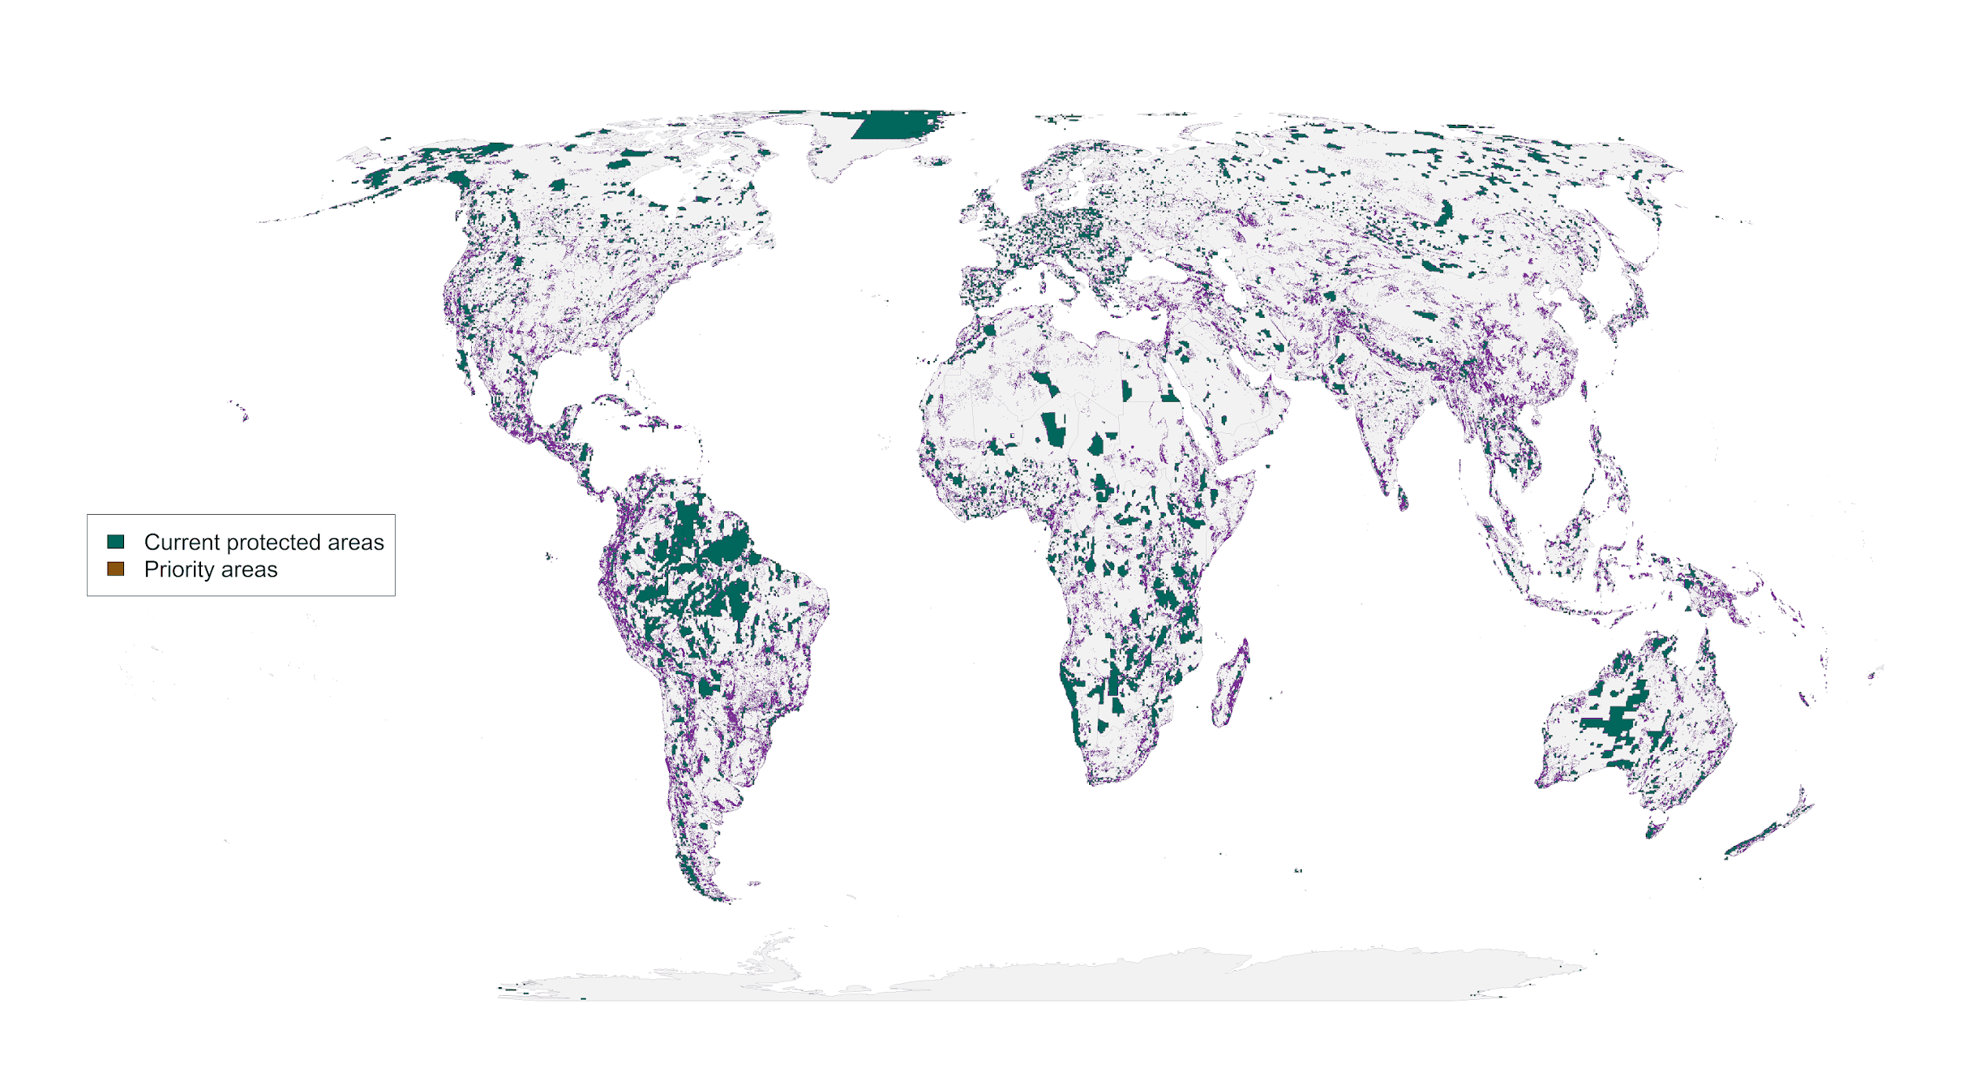

**Figure 1:** Spatial representation of priority areas for protection to account for governance, land use and climate risk. Accounting for these risks to protected area effectiveness to produce more resilient conservation networks would require 23.5% of land surface to reach suitable habitat protection goals (*26*) for vertebrate species from the IUCN Red List of Threatened Species (*20*).

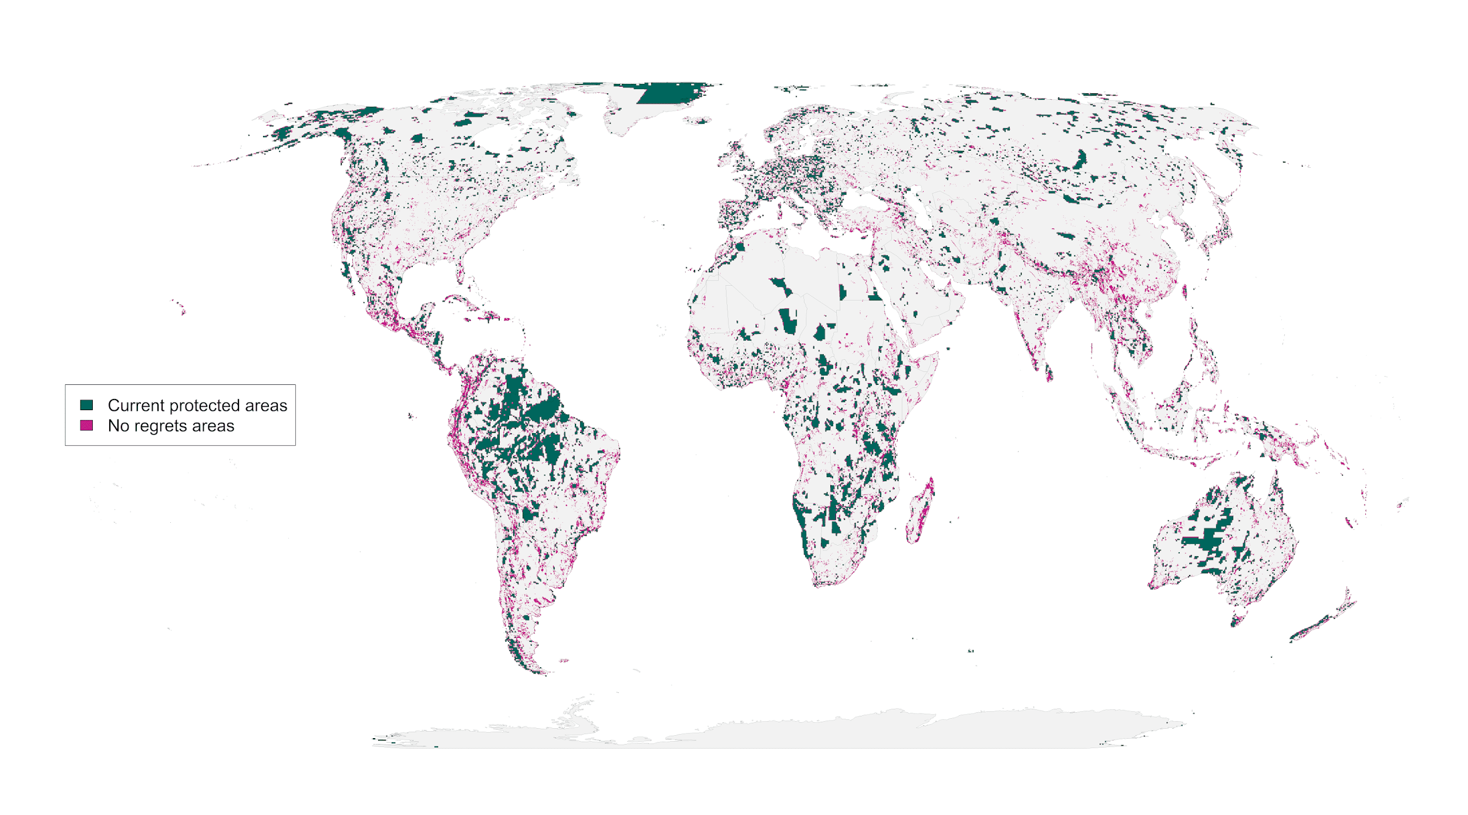 **Figure 2**: “No regrets” areas comprising 8.5 million km2 of land that was identified as priority habitat for protection regardless of the risks included in our analysis.

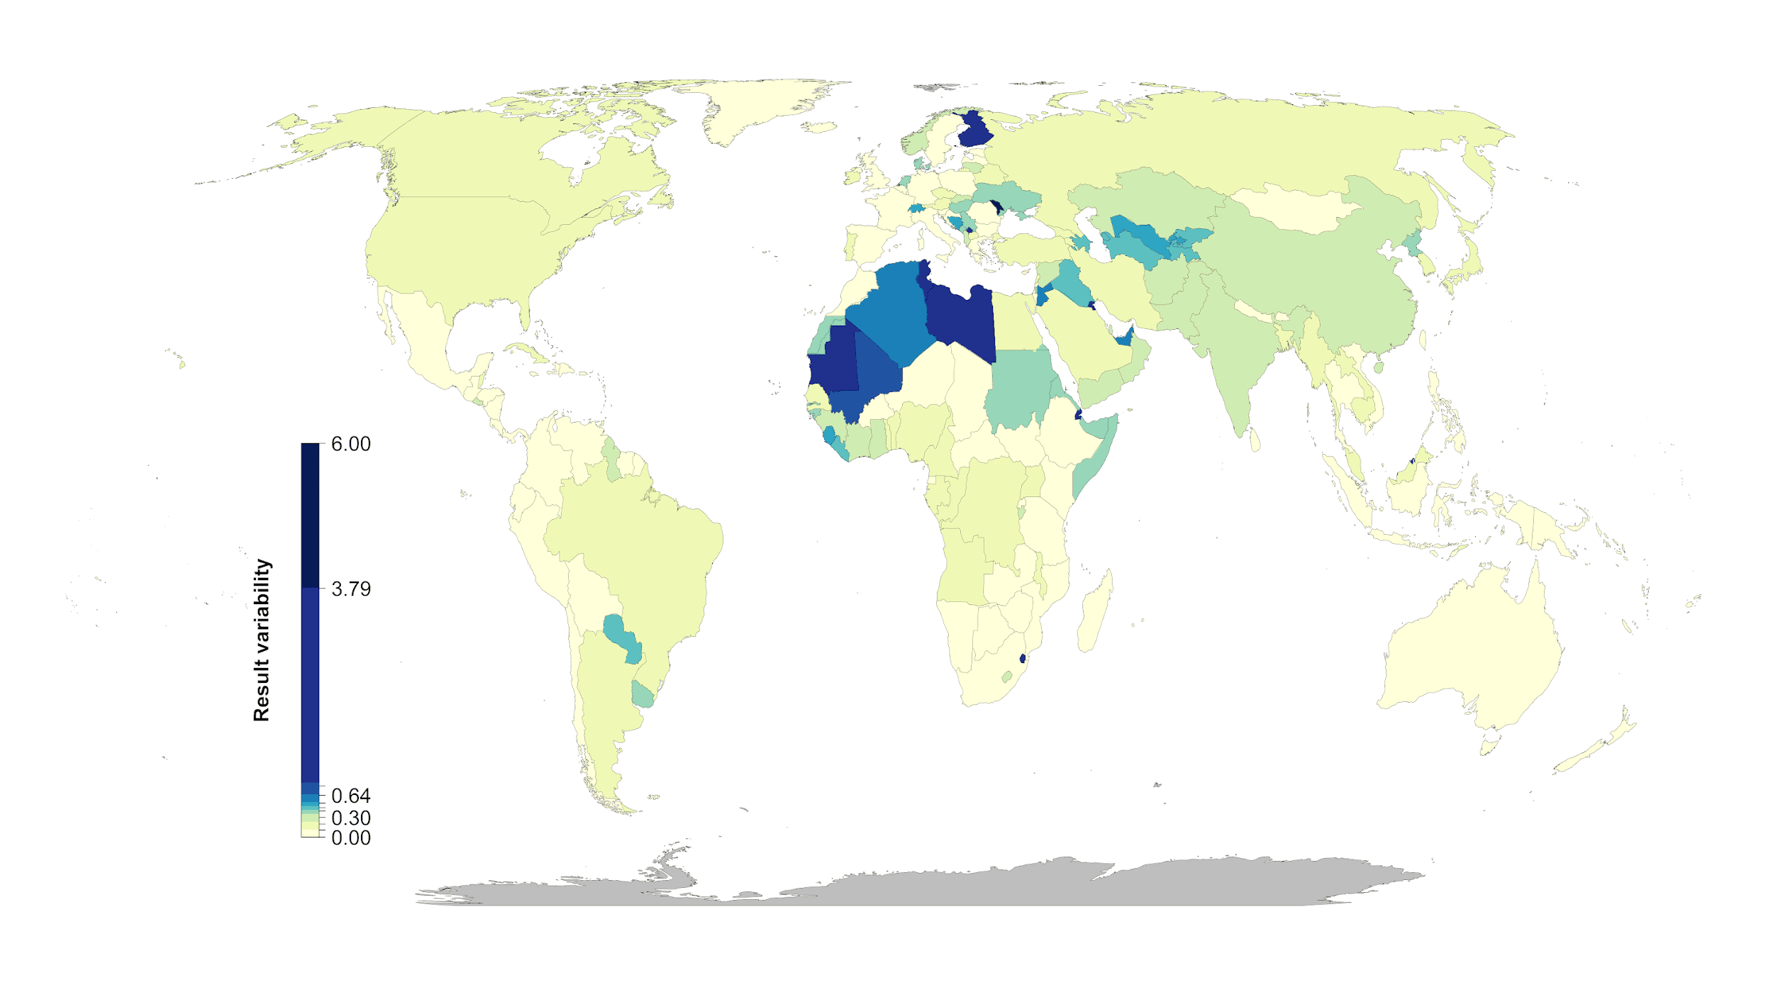

**Figure 3:** Percent country-level variation between the null scenario and the 15 scenarios including risk. Countries whose results are consistent across the 15 scenarios (e.g., Mexico) have low variation, while countries whose results are less consistent across the 15 scenarios (e.g., Finland) have high variation. The kmeans method (*79*) was used to generate class intervals for visualization.

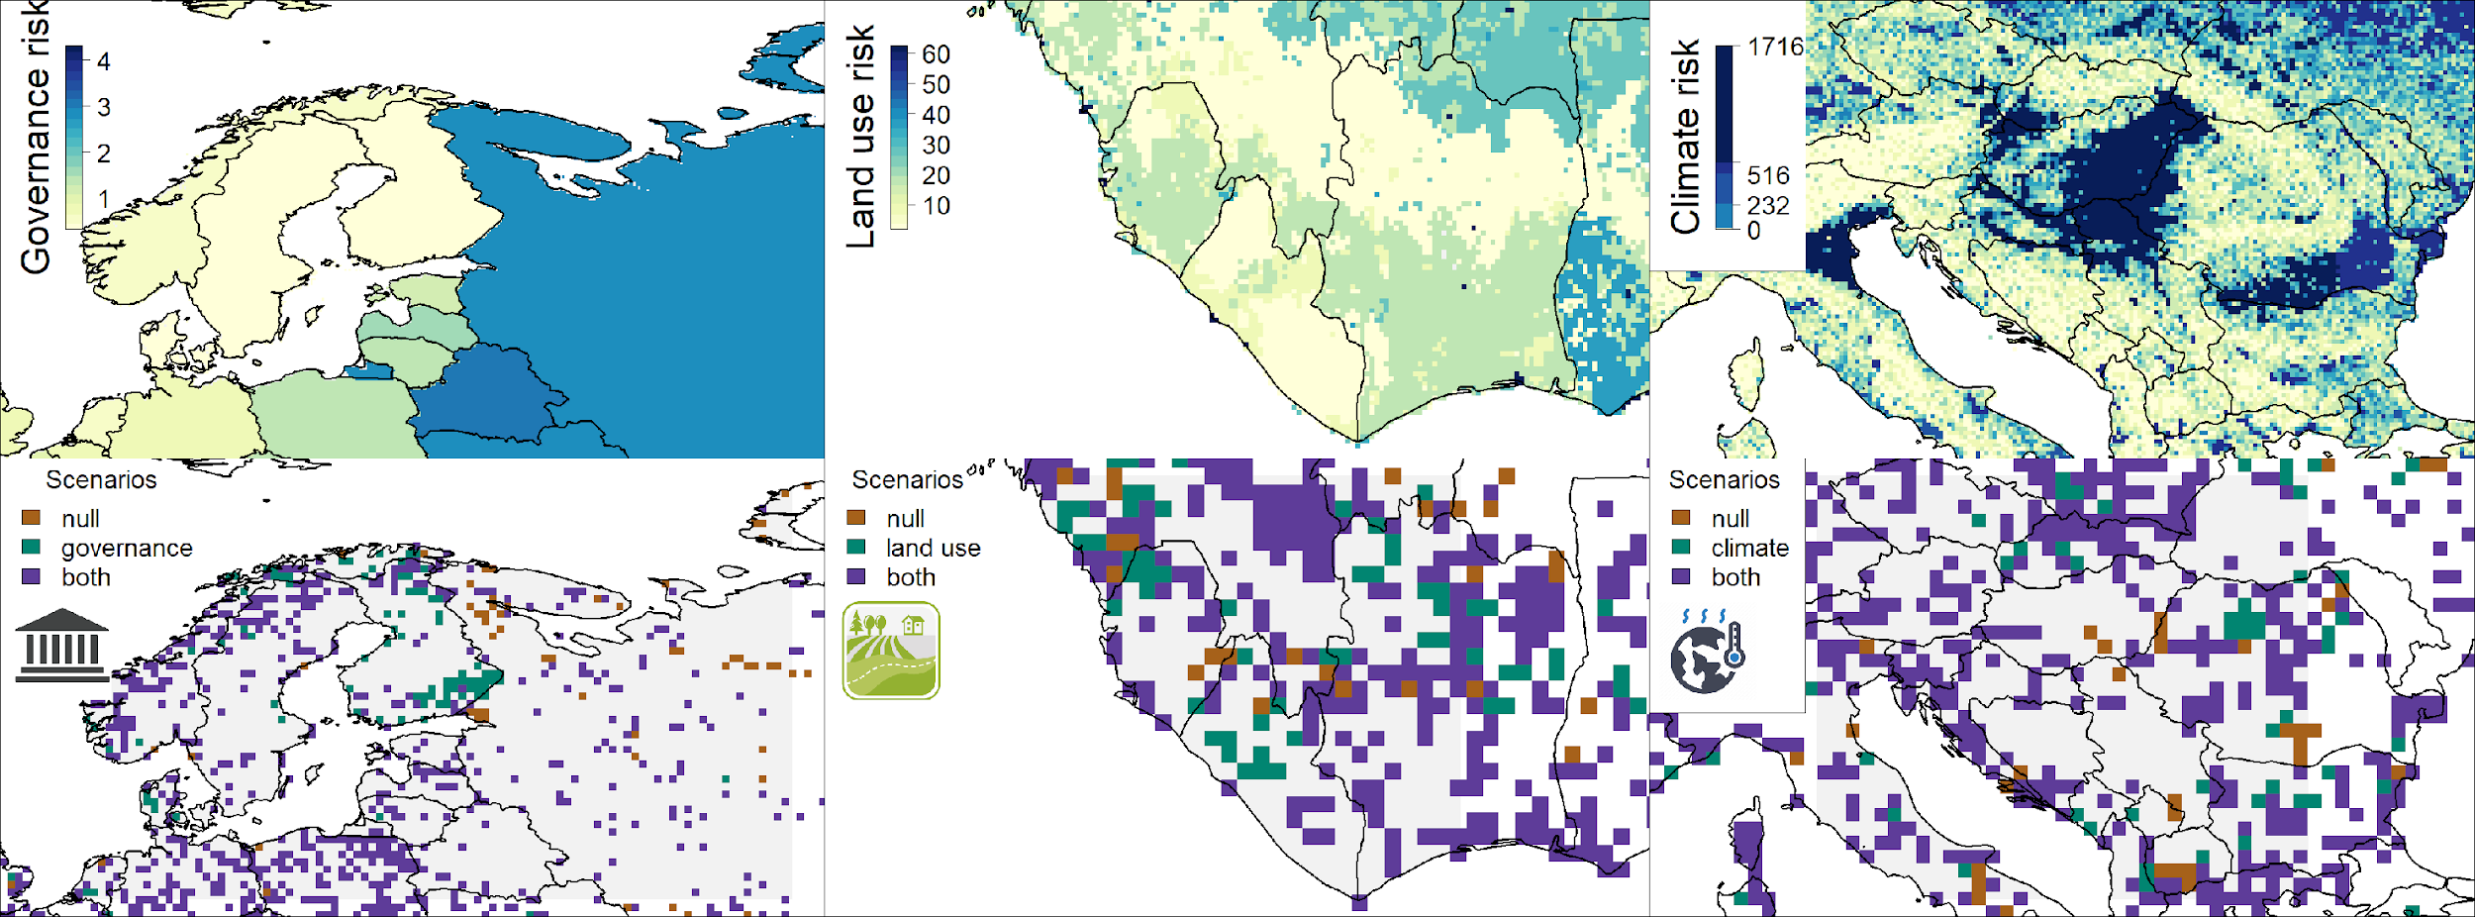

**Figure 4:** Contrast of using individual risk objectives (governance, land use, climate) to the null scenario of uniform objective structure. The top panels represent the individual risk data for the focal regions. In the bottom panels brown shows null, green the specific risk objective scenario results, and purple where both scenarios agree. The figures show how the spatial configuration of the solutions changes when risk is considered in a scenario. Governance focus is on Finland and Russia, land use risk on Sierra Leone and Liberia, and climate risk on Serbia, Hungary and Kosovo.